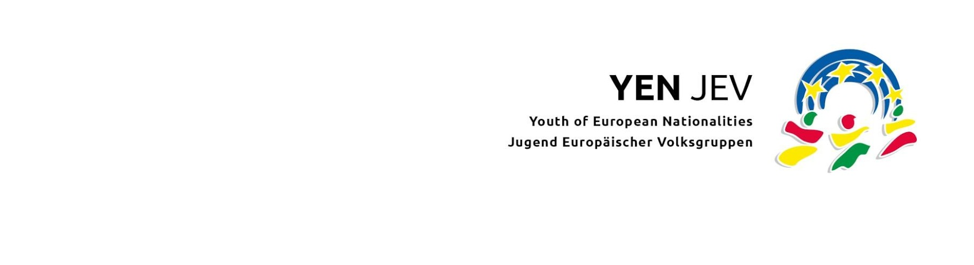

Delegation of voting rights for YEN´s hybrid General Assembly (GA) 2023*

* Possible only between different organisations representing youth from the same minority and country.

Hereby, we the _____________________(name of Organisation), representing youth from the ________________________________________(name of minority) delegate the right to vote at the YEN General Assembly on the 6th April 2023 to _______________________(name of Organisation), also representing youth from the _________________________(name of minority).

Name and position of the legal representative of the organisation:

Date: Signature:

Based on the YEN`s Rules of Procedure:

K.3.b Number of votes
- All minorities represented in YEN by ordinary members have the right to participate in the decisions of the GA with six delegate votes.
- In the event that several organisations of one minority are members of YEN, the votes shall be divided in equal parts among the organisations. If more than two member organisations are not able to agree upon the voting rights, the disputed votes shall be considered as abstentions.
- In the event that one of several member organisations of one minority in YEN is absent, written consent from the organisation concerned is required to enable the present organisation(s) to use the voting rights of the absent organisation.
- One delegate can make use of all of her minority’s votes.

